JFROG INSTALATION AND INTERGATE WITH JENKINS

1. First we need to take one Linux server
2. Install the java8 and set the path like Previous
3. And we need to go JFrog official site and download the zip file its download local system either your using windows
4. 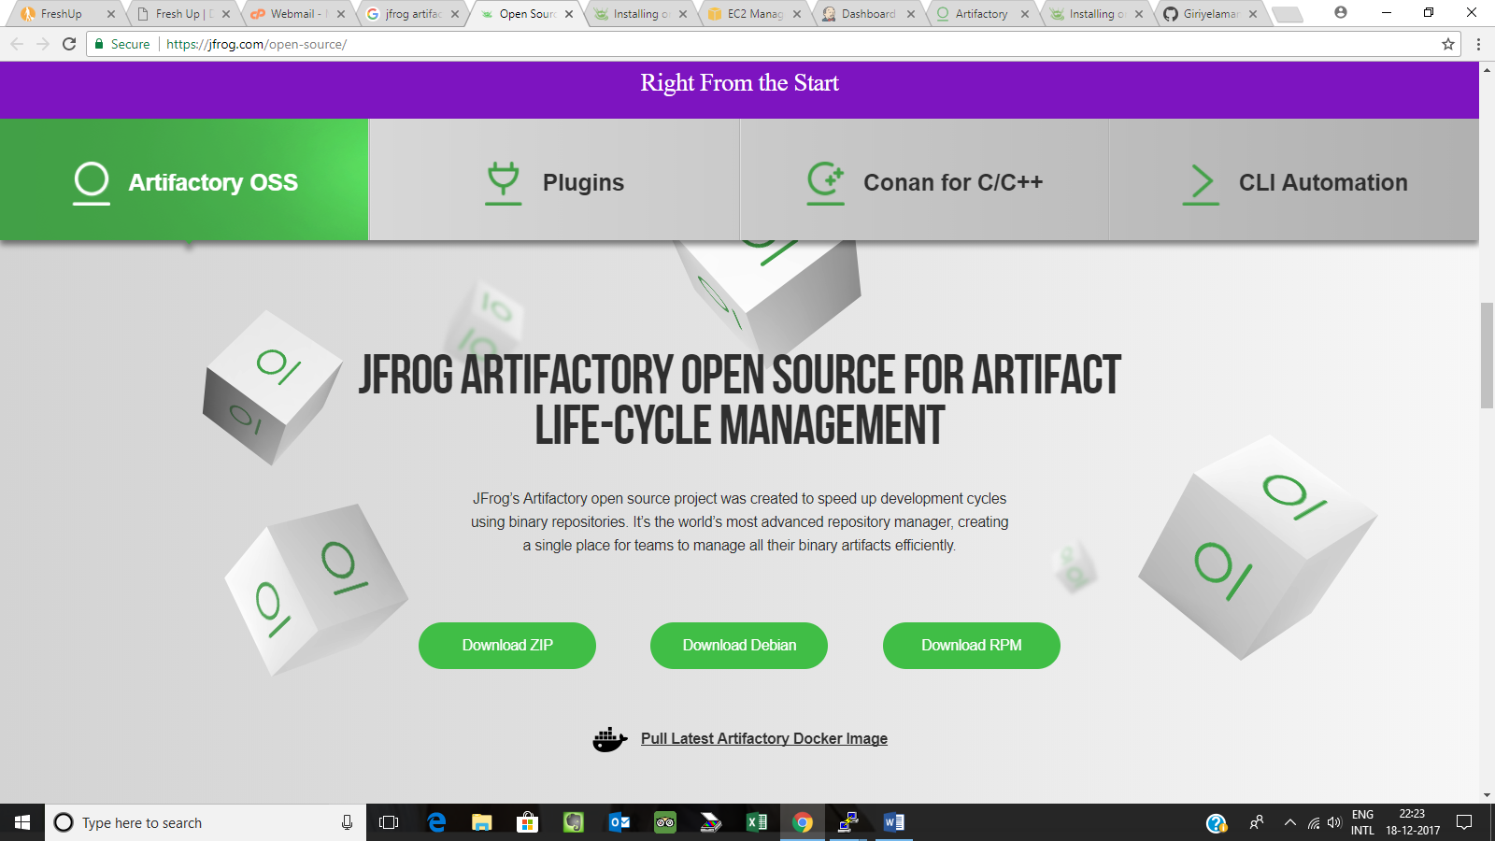
5. Copy the respected zip file into Linux environment from windows by using winscp
6. After unzip the Artifactroy
7. Go to bin folder you can find the **artifactoryctl**
8. and you can start and stop the server using the command
9. **./artifactoryctl start**
10. **./artifactoryctl stop**
11. Jfrog default port is 8081 we need to open that port number
12. Then we need to take server ip paste the search bar along with port like 52.53.242.251:8081
13. Then its look like the console and its default username and password
14. Username :admin password :password
15. Then click the skip or next button
16. And you will found the one example-repository
17. 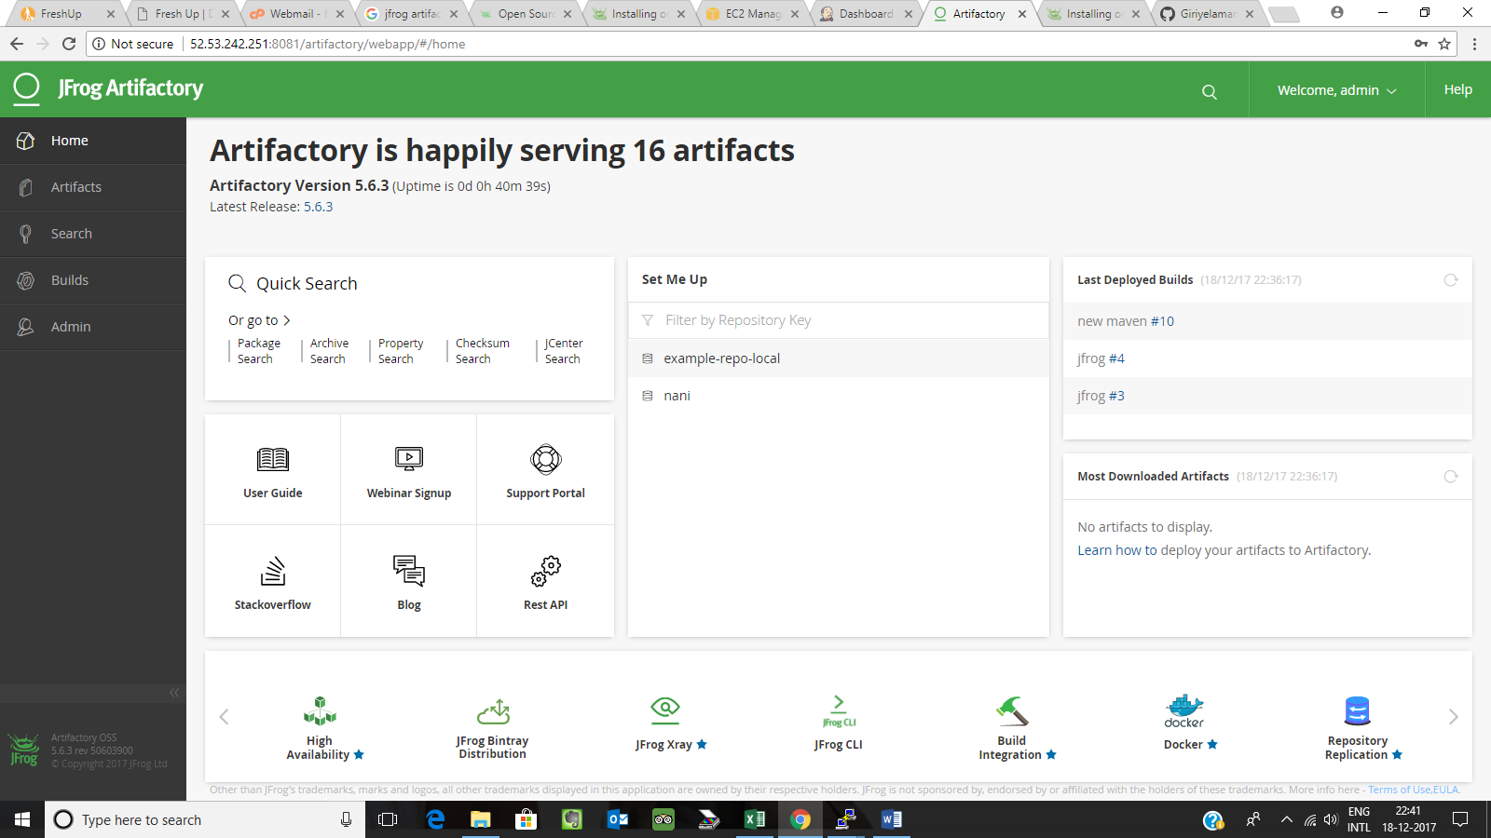
18. **And copy the jfrog artifactory url**

**Integrate with the jenkins:--**

* **Open the jenkins server**
* **Go to the manage jenkins and manage plugins choose the avalible plugins and type the Artifactory plugin and install the plugin**
* **Then go to configure system find the Artifactory and click the Add Artifactory server**
* **You can fill the server id it is the customized name**
* **And you can copy the jfrog server url and paste URL bar**
* **Then test the connection**
* 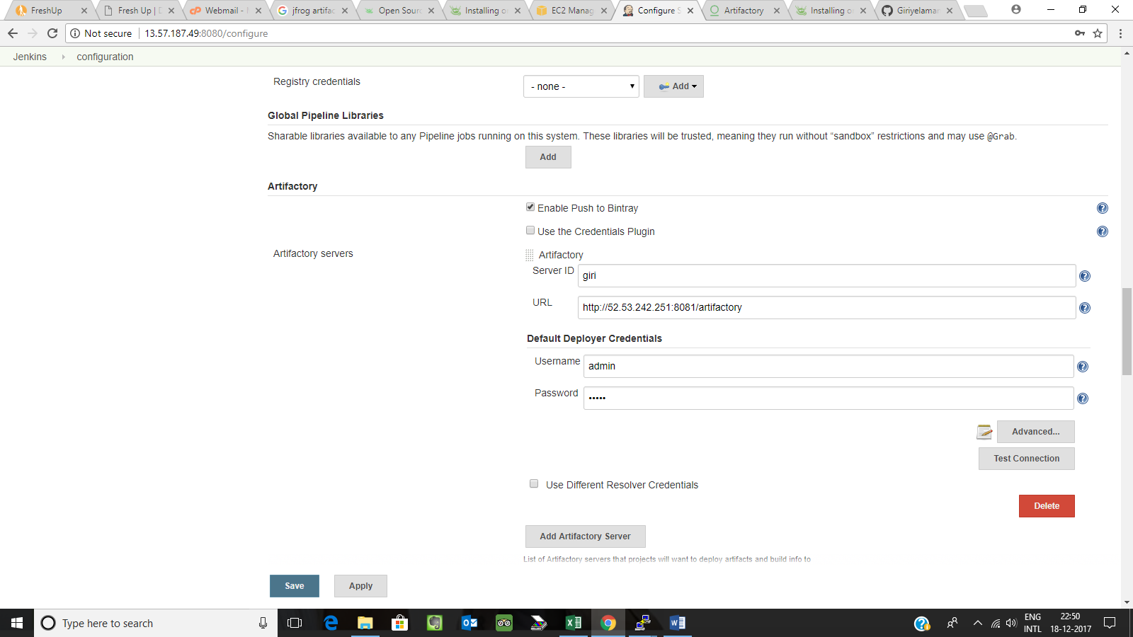
* **And save**
* **Then go to take the New item 🡪 select the maven project**
* **And go to the job configure**
* **And paste the git hub url and select post build actions**
* **Then Deploy the artifacts to artifactroy**
* 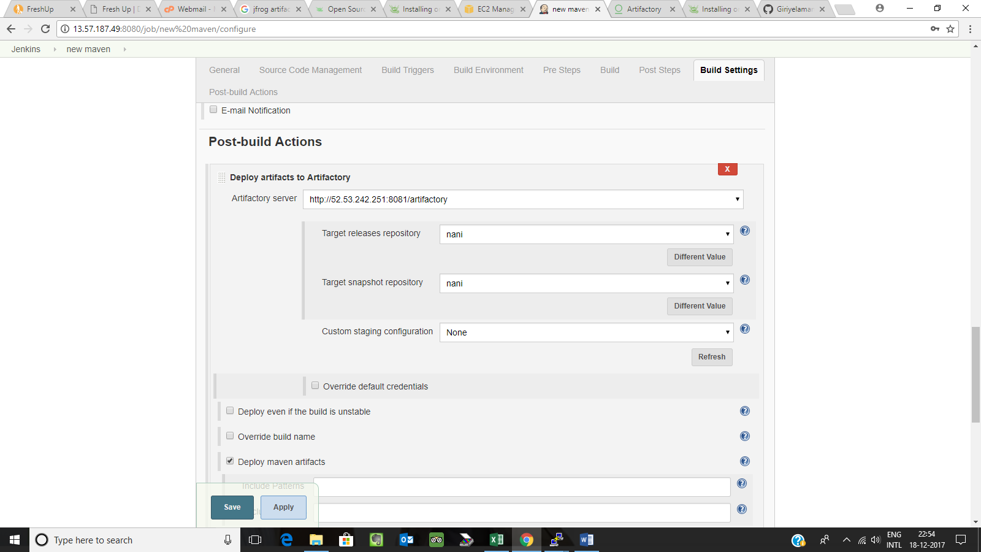
* **Default in artifactory server url**
* **And refesh the below button and select the repository name and save it**
* **Build the job**
* **See the artifacts in jfrog home dashboard**

**A screenshot of a social media post

Description generated with very high confidenceThank you**